A Living Cabinet of Breath Curiosities: Somatics, Bio-media, and the Archive

Kate Elswit

Abstract:

Breath builds intimate and physical connections beyond the individual, at the same time as it also poses challenges to sharing experience with others. However, performance has the capacity to archive multidimensional sensory experience and recompose it in a manner that is palpable to an audience. This essay addresses the problem of collecting, re-accessing, and sharing breath, from the indexing of breath as biodata to the use of ‘breath media’ in performance. The phenomenology of breath is interwoven with critical theorization of contemporary interactive biofeedback techniques, and grounded in reflexive analysis of creative practice, specifically the practice research project Breath Catalogue, in which experimental choreography and technology create a cabinet of breath curiosities in performance. This living catalogue — distributed between bio-media and somatic tasks of embodied memory — is contextualized within medical humanities, archive theory, choreographic practices, digital performance, and feminist technology studies.

Keywords: breath, biosensors, choreography, medical humanities, performance, breath media

Biographical Note:
Kate Elswit is an academic and dancer whose research on performing bodies combines dance history, performance studies theory, cultural studies, experimental practice, and technology. She is author of Watching Weimar Dance (Oxford University Press 2014), about the strange things people claimed to see while watching dances in and from the Weimar Republic, which won both the Oscar G. Brockett Book Prize for Dance Research and honorable mention for the Callaway Prize. Her new book is about the interdependence of Theatre & Dance (Palgrave 2018). Together with Harmony Bench, her digital work has been most recently funded by a three-year project grant from the UK Arts and Humanities Research Council for Dunham’s Data: Katherine Dunham and Digital Methods for Dance Historical Inquiry. Further awards and prizes include a postdoctoral Mellon fellowship at Stanford University, the Lilian Karina Research Grant in Dance and Politics, the Gertrude Lippincott Award, and the Biennial Sally Banes Publication Prize. She received her PhD at the University of Cambridge, and is now Reader in Theatre and Performance at the Royal Central School of Speech and Drama, University of London.

A Living Cabinet of Breath Curiosities: Somatics, Bio-media, and the Archive

Breath Catalogue premiered in San Francisco in 2015, as a collaboration among myself and Megan Nicely as choreographer-performers, data scientist Ben Gimpert who created interactive visualizations, and composer Daniel Thomas Davis (Fig. 1). The work creates a cabinet of breath curiosities in performance. Breath is fundamental to us as dancers and people, and yet itself is curious—assumed and automatic but unpredictable in the ways it shifts through so many dimensions of lived experience and slips between conscious and unconscious realms. In the project, we collect, re-use, and share experiences of and data on the performers’ breathing, using techniques of embodiment coming from experimental dance in conjunction with technologies entangled with theatre and medicine, from biofeedback via wearable sensors to audio recording. Through these methods, Breath Catalogue aims to make the performers’ breath palpable to an audience, engaging with performance as a laboratory in which to explore new means of cataloguing and circulating multidimensional sensory experiences, between measurement and memory. In so doing, it proposes breath experience as a kind of living archival material that can be investigated and re-accessed using bio-media.

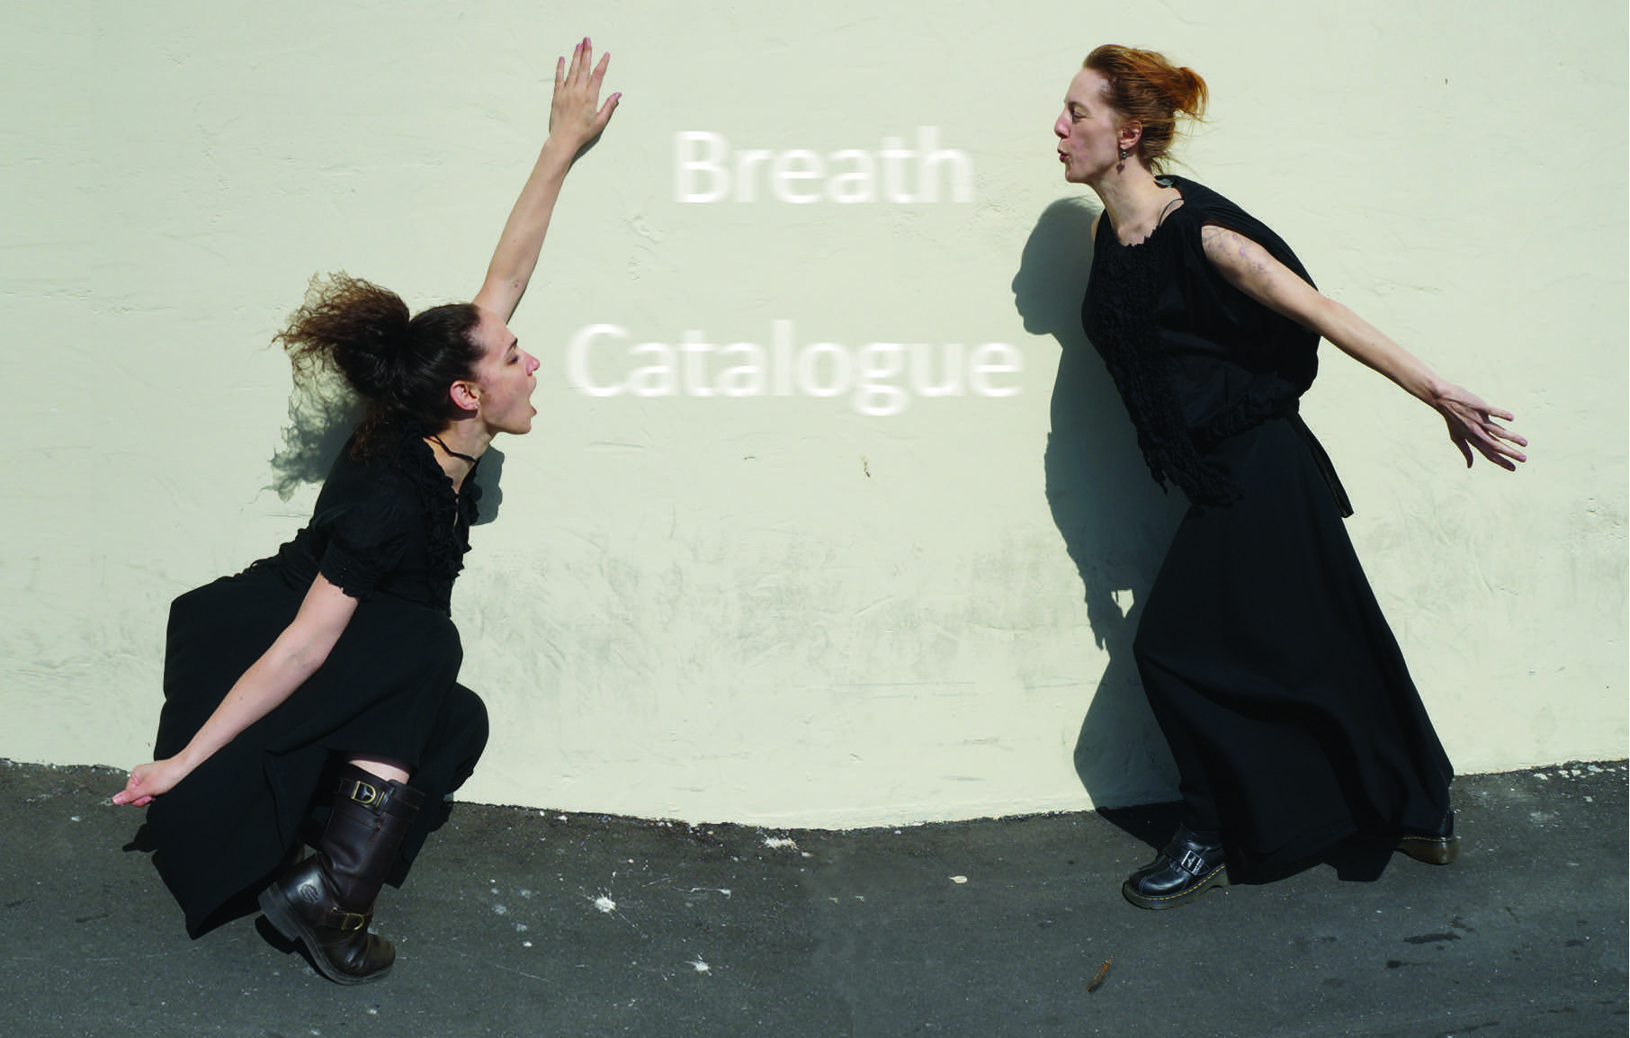
Figure 1. Breath Catalogue promotional postcard image (2015).

Drawing on research initiated through the Breath Catalogue project, this essay first articulates key terms for its living cabinet of curiosities through a series of historical contexts, from early modern projects of curio collection to biofeedback practices of the last half century, as well as conversations regarding dance archives and digitality. I then turn to the phenomenology of breath as well as ongoing research in the medical humanities, to posit the specificity of breath a site for such inquiry. On the one hand, there is the multidimensional nature of breath, specifically the extremely intimate and physical connection that breath builds beyond the individual. Yet at the same time as breath represents the body at its most permeable and thereby deindividuated, it also poses challenges to collecting the individual lived experience to share it with others. I elaborate one such challenge in the indexing of breath among other bodily sensations as data, before opening out to the role performance can play in teasing out the fraught relationship between biodata and physical experience. The second part of the essay demonstrates the ways in which Breath Catalogue negotiates these questions, first through a choreographic practice that disentangles the intrinsic connections between breath and movement in tandem with technologies of breath capture, and then through a bio-media practice that extends these processes using sound, live and recorded data, projected visualizations, and visualization objects.
The evolution of ‘bio-media’ reflects a shift of digital practice toward a broader field of contemporary physical performance. I use the term ‘bio-media,’ and more specifically ‘breath media,’ in a broad sense to describe the collection and sharing of breath both through sensor-derived data, as well as through other digital forms, including film and audio recording. The use of biosensors in artistic performance is most commonly dated to the 1960s (see Dixon 2007; Salter 2010), however such early works tended to operate in a framework that privileged causality and control in more simplistic mappings of the bodily sensor data collected, often movement or heart rate, to some form of analog or digital output. While the 1990s are better remembered for the proliferation of screen-based interactions, based on advances in motion capture and telematics among other areas, biosensors became small enough to be more easily worn on a performer or participant’s body, and there was enthusiasm for their potential in creating reactive performance environments controlled by gestural or sonic inputs (deLahunta 2002; Birringer 2008). By the third wave of digital interfaces, far more intricate interweavings of interoceptive (somatic) and exteroceptive (technological) agency emerge, which ultimately understand performances as themselves new ‘viewing-sensing devices’ for both performers and audiences (Davidson 2016, 22). Artistic collaborators Nacarrato and MacCullum characterize this transition as that from ‘biocontrol’ to a kind of ‘biorelational feedback’ that is attentive to the processing, mediation, and/or feedback loops between data, output, and performer (2016). This developmental trajectory tends to privilege an inside-out approach to biological processes, emphasizing the qualitative aspects of experiences such as breathing over quantitative performance management, among other things because of the ways in which they draw on training from yoga and martial arts as well as Eastern medicine (Kuriyama 2011).
As I began to collect examples at the conjunction of breath, technology, and performance specifically, it seemed conspicuous that breath was a more common bio-measure in late 1990s and early 2000s performance and media projects than today. At the time, these ranged from influential high-budget projects such as the VR immersive environments Osmose (1994-95) and Ephemere (1998) by Char Davies and Softimage, to more experimental work, interconnected with academic research, such as the interactive installation Whispers (2002) led by Thecla Schiphorst and Susan Kozel, and the promenade performance Pulse (2003) by visual artist Lynn Lukkas, Paul Verity Smith and Kelli Dipple, dancer Maria Stamenkovic Herranz, and composer Paulo C. Chagas at Johannes Birringer’s Interaktionslabor creative residency. Whereas such projects were premised on a kind of enthusiasm about the potential of breath as a means to push expressive embodiment in media practices, the challenges of data collection around breath specifically made it less common as technological capacities increased more significantly in other areas, such as motion capture. Looking back, some of these artists in fact attribute their turn to alternate practices to the difficulty of the technology (Davies 2018; Lukkas 2018). Even as the particularities of capture and mediation of ‘micro-movements’ such as breath have emerged again as important today, it is in service of developing more realistic encoding of bodies in animation and motion capture rather than seeking to represent the complexity of breath as such (see Karreman 2017). Belonging to the third generation of intermedia work, Breath Catalogue models curious choreographies of the quantified self that build on the potential for intricate feedback loops between body and technology in the development of new sensory and sensible forms, while acknowledging the multidimensional nature of breath itself, which already layers sensibilities.
The idea of creating a ‘cabinet of breath curiosities’ that uses intermedia methods to collect, re-access, and thereby share breath experience draws on the historical European cabinets of curiosities from the 16th to 19th centuries, which served as ways to gather together and display disparate objects (Figure 2). Although the particularities changed over time, Christine Davenne describes such cabinets as ‘laboratories of epistemological and social mutations’ because of the multimedia ways in which they combined diversity with form to patch together links between worlds (2012, 203). The natural coincided with the artificial, science with art, family genealogy with the scientific and divine. Through such practices of collection, desires for knowledge overlapped in different ways with experiments in display and organization. As much as historical cabinets were about accumulation, they were also about marking the unknown (see Mauriès 2011). The cabinet thus connotes the use of curiosity to actively construct a non-totalizing world view, in which there is a back and forth between collection and classification—a blurring between the cabinet and catalogue, whereby collection is always entangled with articulation and re-presentation. Breath Catalogue draws on this model, but with lived experience as object, from the identification and development of distinct breath ‘curios’ with particular properties and patterns, to a set of somatic and staging choices that support the performers in the practice of retrieving the specificity of each breath curio and recomposing it before an audience.

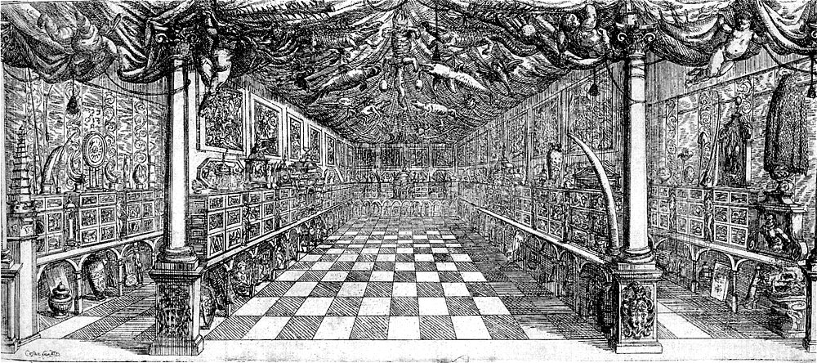
Figure 2. Manfredo Settala's Cabinet of curiosities (1666).

Such a living cabinet of curiosities has resonances with conversations concerning how embodied performance functions as both a kind of remains of the past and also a means of reengaging with it, including in relation to dance’s digitally mediated circulation. The ‘archival turn’ in performance has emphasized the dual imaginative and historical work of the artist as curator of and interlocutor with archival materials that are reprocessed through their practice (see Franko 2017). This includes the recorporealization of digital dance archives back into the bodies of dancers (Whatley 2013). At the same time, there is a tendency to for such projects to engage with known archival referents (Elswit 2014a). Further, while so many discussions of dance, digitality, and archives occur in relation to asynchronous circulation and the proliferation of dance’s publics beyond body-to-body contexts, including via social media (Bench 2016; DeFrantz 2012), I focus here on a kind of idiosyncratic saving and retrieval that is medially entangled and reaches across time but within shared space. In this sense, I find it particularly useful that Rebecca Schneider, who gave us the formative language of performance’s different ‘remains’ and the distinction between flesh and bone in 2001 has recently reframed this in relation to intraanimate participation of both flesh and bone in the media event, which may predate and out-remain one another (2018, see also 2001).
When I describe the collection, re-accessing, and sharing of Breath Catalogue, then, I refer to a kind of living archival practice that engages with the pasts and presents of breath experience to produce a catalogue housed in distributed form — between bio-media and somatic tasks, which take a non-naturalistic approach to the facilitation embodied memory. Each ‘curio’ of our catalogue is an investigative event comprised of variations on four layered elements, and the relationship among them is renegotiated every time a curio is recalled from the cabinet. First, there are the particular qualities or dimensions of breath that are being explored, formulated as a question, challenge, or other prompt for inquiry. Then there is the precise movement score that serves to nuance our engagement with the curio’s breathing patterns as themselves already deeply choreographic. Third, there is the interaction with breath media that may form a part of the core inquiry or support it, but regardless plays a role in the archiving and recomposition of a curio’s properties as distinct from others in the cabinet. Finally, there is the audience. While a public performance of Breath Catalogue, like the earlier curiosity cabinets, ultimately selects and orders a set of curios in order to place various aspects of breath on display, the collection is not shown but shared, with the living breath investigation recomposed before an audience in a manner that implicates them as also embodied subjects with manifold breath experiences, memories, and associations.

Breath and Palpability

To think about the sensible qualities of breath engaged as archive before an audience requires first dealing with breath as already a medium that tangles with palpability, moving between bodies at the same time as it challenges the limits of perceptibility. This material quality of breath was viscerally apparent as I drafted parts of this essay during the 2017 Northern California wildfires; in the time it took me to alternate grieving for the thick air outside and putting words on paper, 210,217 acres of forests and homes burned, and I felt the particulate matter of people’s lives in my chest with each breath. Breath consists of intercorporeal and intracorporeal circulation, both external respiration in which gasses are transferred between the respiratory organs and the outer environment, and internal respiration that occurs at a cellular level. A gas saturated with water that can undergo state changes, breath also has a robust and sometimes visible life outside of the body as force, heat, and moisture, most familiar from the cartoon-like clouds that form outside our mouths in the cold. But it goes the other way too—not just inside out, but outside in, as during the wildfires. This potential for exchange is heightened by the ‘flexible’ nature of breathing, by which breath occupies a unique status as both voluntary and involuntary, the only major function of the body that is managed unconsciously in a manner that can be overruled by conscious control (Eccleston 2016, 79; see also Calais-Germain 2006).
Beyond tactility, breath’s circulation ties more broadly to perceptibility. A text from early Greek medicine that belongs to the Hippocratic corpus addresses this permeability when it identifies wind as a key form of human sustenance but clarifies that ‘Wind in bodies is called breath, outside bodies it is called air.’ This passage has recently returned among new materialist arguments, to highlight the inextricability of self and environment, as well as the vulnerability of bodies in the Anthropocene (for example in Klingan 2015). However, the fluid relationship between breath and air also positions breath in relation to the flow and float of ideas themselves, as they leave one body and enter others. Here one might think about Steven Connor’s argument for the historical role of air as a mutable mediator between thought and the world (2010), and feminist philosopher Luce Irigaray’s suggestion that a turn to breathing and with it air might counter the historical insistence on logos or the ground alone (1999).
Patterns of breath can also be used intersubjectively to tune individual proprioception toward and ultimately connect multiple bodies, from artistic practices to religious ritual, as well as offering means to reflect on wellbeing. For example, in many contemporary dance practices, music is not counted to regulate movement; instead breath coordinates the sense timing of a group of movers. An inhalation may offer a moment to suspend and re-collect, with the exhalation serving as the impulse to attack the next movement phrase together. This connection to others is further reinforced by the relationship of breath to sound and voice. In Blackpentecostal Breath, Ashon Crawley explains how breath provides the base for the whooping, shouting, and speaking in tongues that ultimately also mobilizes affect among the community (2017). Hearing breath is associated with both illness and wellness, from the labored breathing of asthma to the ujjayi throat-lock breath practiced in Ashtanga yoga or the codified breath techniques of labor. And the relationship between sound and breath is further connected to mortality and breathability as determining one’s capacity to be in the world, from the infamous ‘death rattle,’ to Eric Garner’s repeated last words, ‘I can’t breathe,’ the repetition of which eleven times while lying face down on a New York City sidewalk has now become a metonym for the stifling conditions of living under militarized policing practices, and the structural racism that mobilizes them. To think of this in terms of the political matter of bodies: ‘some lives are breathable, others are suffocating’ (Górska 2016, 24).
Implicit in the previous paragraphs is how quickly breath slips between anatomically-located information to affect. To make this affective dimension more explicit: breath can call forth or be called forth by various feeling states, including fear, mindfulness, anxiety, surprise, and pleasure. Recent studies in clinical neuroscience focus on the ways in which sensations and impacts of breathlessness are modulated by emotions (Hayen, Herigstad, and Pattinson 2013). For example, escalating cycles between feelings such as panic or arousal and hyperventilation, support a ‘developing view of panic as a consequence, not the cause, of respiratory reaction’ (Eccleston 2016, 94). As such, breath also has an intimate link to other physiological patterns, including heart rate. If your heart is racing, you tend to be told to take a deep breath, and mindfulness techniques and meditation likewise extend this connection between breath and corporeal temporality, using attention to breath as an anchor to the present state of the body and consciousness. At the same time, researchers push for thinking beyond the symptom/syndrome altogether, to deal with ‘breathlessness as something that might not directly correspond to airway pathophysiology, and which may need to be treated both in parallel and independently of the lungs’ (Faull et al. 2018, 1). It is no wonder then that breath has tended at various historical moments to be connected not just to the psyche and thought, but also the soul (see Fitting 2015).
This collection of examples evidences how breath might be seen to generate environments in which extreme physical and felt connections can be shared. However, at the same time as breath contributes to making the body permeable to the world, it is challenging to make that lived breath experience perceptible to others, and discrepancies arise between various means of collecting and thereby articulating breath experience. A key argument for the need for new, interdisciplinary methodologies to better account for breathing and breathlessness comes from philosopher Havi Carel and medical anthropologist Jane Macnaughton, co-investigators on the Life of Breath research project. As Carel explains: ‘A well-known enigma in respiratory medicine is the discrepancy between objective lung function, as measured by lung function tests, and subjective feeling and function’ (2016, 118). In other words, lived experiences of pathological breathlessness tend not to correlate to the ways in which lung capacity is descriptively understood by standard forms of pulmonary function and respiration testing. Yet, ‘breathlessness has for the most part been subsumed by objective measurements’ that therefore do not come close to describing what many patients describe the all-consuming nature of breathlessness (Carel, Macnaughton, and Dodd 2015, 278-279). This challenges not only diagnosis and treatment, but also quality of life, whereby those living with Chronic Obstructive Pulmonary Disease (COPD) and other respiratory conditions often report feelings of isolation from loved ones, due to constraints not only on participation in physical activities, but also on their capacity to share lived experiences. Instead, Macnaughton and Carel argue that understanding the full pathophysiology of breathlessness requires finding new methods in the critical medical humanities to bridge the ‘epistemic gap between clinical knowledge and two other interlinked kinds of knowledge: the broader cultural knowledge within which clinical knowledge is tacitly nested and the idiosyncratic personal experience of breathlessness, also informed by culture and later by encounters in the clinic’ (2016, 297).
New ways to share breath are therefore necessarily entangled with new means of collection capable of engaging with the multidimensional nature of breath experiences on their own terms. While the diagnosis of COPD-related breathlessness has come to include observations regarding qualitative language (Williams et al. 2008), this still relies on a narrow and relatively literal vocabulary. Writing about techniques for ethnographers to attend to and translate the embodied experiences of kinesthetic cultures, Samudra points out that ‘normal sensory language does not always provide vocabulary for deep somatic experience’ (2008, 673). Rather, Samudra pushes for a bespoke metaphorical language to describe new sensations that go beyond the five senses. With Breath Catalogue, we likewise pursue this through the role of scholar-artist as a collector of breath experience, but without the incentive toward translation into scholarly writing. Rather, we work to attend to the thickness of breath experience, and to gather these many dimensions into equally thick yet specific curios thereof. At the same time as the sharing aspect of this cataloguing practice rests on the well-understood idea that the dancing body “formulates an appeal to viewers to be apprehended and felt” (Foster 2010, 218), this is both settled and unsettled by doing so in relation to bio-media and specifically breath media. While dance has often served as a metaphor or threshold for technological possibility, dance-based approaches in combination with technology have the chance to recompose not only individual sensations of the body but also their share-ability. Discussing the combination of intermediality with respiration, Goudouna points out that artworks focusing on the physicality of respiration tend to prioritize viewers’ embodied reception at the same time as such works often push on the dual nature of body physical presence and the intermedial body (2018, 17, 26).
Although breath occupies a fascinating position in histories of measurement as impetus for the first systematic quantification of the human body in the 1840s, breath continues to pose challenges to technological capture, even today. Macnaughton and Carel’s concerns about the limitations of collecting and sharing breath as data, even in the most robust clinical settings for measurement, and their argument for building medically meaningful communication around a broader repertoire of lived breath experiences, resonate with contemporary discussions in technology and media. There is a substantial literature on the tensions between biodata and other sensory modalities, regarding the ways in which measurement may augment, compete with, or even potentially replace other means of making one’s experience visible to oneself (Lupton 2013; Whitson 2013; Cohen 2016; Sharon and Zandbergen 2017). One example is how technologies of the quantified self tend to treat the body as an object to be disciplined according to narrow parameters, rather than expanding corporeal registers of feeling, when in fact there needs to be more emphasis on the complexity of transitions “between feelings and numbers” (Schüll 2016; Crawford, Karppi, and Lingel 2015, 489). Already in 1998, affective computing pioneer Rosalind Picard raised concerns about how developing wearable technologies were ultimately being used primarily to increase the efficiency of workers, instead proposing the potential to increase ‘affective bandwidth,’ an idea that media scholar/artist Susan Kozel addresses in characterizing her own work as ‘wearables for the telepathically impaired’ (Picard 1997, 57; Kozel 2007, 282). Further studies reiterate that such affect is not disembodied; rather, somatic practices offer interdisciplinary frameworks to contribute to technological understandings of embodiment and experience, to ultimately shape design, creativity, and use (Schiphorst 2009; see also Bleeker 2010; Kozel 2007).
Performance-based techniques of sensory experience push the ways in which bio-media might be understood to participate in collection and re-accessing. In her study of surveillance technologies in performance, Morrison connects the logic of theatrical naturalism with biometric science, in order to articulate the potential of avant-garde performance and media practices to intervene in seemingly objective representations of the biologically legible body (Morrison 2016, 189, 194). On the one hand, performance and media works that engage with biodata may lend themselves to stagings that emphasize the constructed, even spectacular nature of the knowledges for which that data stands (see Drucker 2011; Magnet 2011). But, on the other hand, the flawed and incomplete nature of biodata also offers opportunities to think more closely about such performances themselves, and particularly the ways they share bodily experience by means of feedback loops built on partial data, that may yet, or in fact better, give access to the multidimensional nature of that experience. In this sense, I argue elsewhere that breath data itself needs to be reconsidered by means of a ‘performative measure’ in order to bring into focus the ways in which technologies make multiple dimensions of breath experiences legible to oneself and others, through—rather than despite—the partial, incomplete, and uncertain breath data on which they rely. Breath Catalogue makes literal that impulse, building a set of practices that do not take breath’s palpability for granted, but instead use a combination of somatic tasks and breath media in order to test performance’s capacity for the collection and sharing of breath experience.

Complicating the Intrinsic Connections between Breath and Movement
Whereas in a ‘normal’ dance show, the breath would tend to be obscured behind lots of movement that it supports, our project in Breath Catalogue is to shift that hierarchy: to keep multiple dimensions of breath not only perceptible to spectators, but in fact as a priority in how they watch a moving body that has all sorts of other things going on. At the same time, as scholars who work on the relationships between medical imaging and art have pointed out, there is also the problem of, in Petra Kuppers’s words: how to ‘weave together the phenomenological emphasis on experience and embodied action together with a trajectory towards deconstructivist unknowability’ (2007, 2). We discovered that making our catalogue of breath experience palpable necessitates creating a theatrical situation in which breath is not collapsed with the individual body of the performer, but rather circulates through her at the same time as she actively manipulates it. The palpability of the breath is therefore not presumed as inherently communicative, but is made more so precisely in moments at which, even if denaturalized, it can be witnessed as an attentive embodied practice.
The somatic practice at the core of Breath Catalogue complicates the intrinsic connections between breath and movement. Many dancers are trained to use breath as a way to control their individual physicality, ranging from anatomical support—for example inhale on spinal extension, exhale on flexion—to ideokinesis where we imagine things like sending the volume of breath into the pelvic floor or the toes (Calais-Germain 2006). Breath is also a way to regulate the relationship between multiple bodies through sense timing, as I’ve noted previously. But what happens when, instead of relying on breath to support movement patterns, we ask breath and body to move autonomously? This experimental choreographic question emerges for Breath Catalogue out of an intermedia process of collecting and interactively using and re-using breath data and other breath media, that I elaborate in the next section, at the same time as it develops as stand-alone physical practice. Beyond the choreography itself, we further reinforce this by staging a multilayered breath environment, both intrinsically with the configuration of the stage as a narrow runway, in which the performers are in close proximity to the audience and it is often difficult to apprehend both breathing performer and breath visualizations simultaneously, and extrinsically by performing where possible in sites with heightened wind, from a former firehouse at Fort Mason at the edge of the San Francisco Bay, to a site-specific promenade version of Breath Catalogue, which took place across a farm in Northern California.
By adapting the choreography to what the sensors and other recording technologies demand of the body, we begin to understand how these two forms of expertise feed into one another. In terms of wearable sensors, we worked first with prototypes of consumer breath monitors that consisted of a pressure sensor and a tri-axis accelerometer, and later with capacitance-based resistance bands built for athletic performance, and the sensor data was processed from both using digital interaction software that Gimpert built specifically for the project (see Gimpert 2015; Elswit 2014b, 2015). These sensors and other technologies of breath capture support disentangling of the naturalness of conventional somatic relations between the individual body and breath, at the same time as they also extend the interface between multiple bodies, calling attention to the ways in which breath positions us in tangible and intangible relation to others. However, at the same time as this kind of practice has the potential to make breathing visible in a way that is otherwise impossible for the dancing body alone, there is also a massive difference between our expert dancer experiences of breath and the dimensions of breath a particular monitor can quantify. Even presuming a breath indexed only by means of thoracic expansion, the hardware picked up certain types and speeds of breathing better than others, we had to find movement and technological languages, curio by curio, that supported the development and translation of that specific breath experience for audiences. The collaborative problem-solving of the studio work in terms of such classification ultimately influences the overall structure and feel of the live performance, from the silent agreement between performers and technologist regarding the starting moment of each curio, to how the inquiry of each is reanimated in front of an audience, rather than presumed as known.
Some of our simplest curios consist of investigative events based on singular tasks that Nicely and I developed to disentangle body and breath. For instance: what happens if you breathe fast and move slow at the same time and vice versa? This solo alternates periods of rapidly pumping breath through the nostrils — like the ‘breath of fire’ from Kundalini yoga — to accompany butoh-like, continuous movements of furling and unfurling the body, then reversing the pattern to pair long, sustained inhalations and exhalations with a fast, twitchy, space-eating dance. Can you choreograph coordinations between inhalations and exhalations the way you choreograph movement? A unison duet worked with a sharp sniff inhalation, then the breath held through a contemporary, Trisha Brown-esque movement phrase, ending with a heavy audible exhale as the final gesture deposits the bodies ninety degrees clockwise from the original facing to begin the phrase again with a new sniff. While the activity of repetition and the concomitant fatigue increases the challenge of this temporary holding, the phrase itself needs to maintain a consistent speed, regardless of physical impulses to the contrary. ‘Sniff Unison’ is performed to four walls in condensed form, then repeated again full out, except that, at walls two or three, the performers are allowed one additional inhalation and exhalation, if necessary. Can you move, breathe, and tell a story at the same time while keeping all three on separate tracks? A solo lecture performance that maintains simultaneous but distinct flows and eddies of voice/language, dance, and breath. Clearly, dance affects voice, voice depends on breath, and breath is modified by dance, however this curio aims to hold a conversation with the audience in such a way that calls attention to these three as interwoven, yet not entirely interdependent.
While these curio fragments arise out of individual propositions, their executions all sit on the foundation of a practice that trains the mover toward undoing habitual relationships to breath. One of the basic warmups that we developed involves setting an even breath for inhalations and exhalations — say a three or a six count — and then beginning to move, slowly and with a sustained quality at first, while resisting the impulse to begin or resolve movements at the end of the inhalation or exhalation. Instead, we use this warmup to acclimate to disentangling, to witness the ways in which we slip into more tethered patterns, and to find new techniques of pushing the track of the body across that of the breath, for example forcing a gesture to continue beyond what may instinctively feel like its natural resolution, which in turn opens less familiar pathways. After the tracks are established using a measured breath against a sustained movement on the ground and then vertically, we begin to let the evenness of the breath and the movement speed go. We continue to maintain the distinction between the two, while looking for moments at which they might begin to refract off one another to build or accelerate. In the final stage of this warmup exercise, we incorporate attention to each other’s breathing and movement tracks as well. Another related warmup pushes this final stage farther: one person is a designated breather, and shadows the mover, watching their movement closely and ‘breathing for the other’ while the mover tunes into that breathing, responding to it as though it is their own.
Such provisional separations enable us to access forms of breath that circulate independently of a single bodily experience. Instead of breath being the ‘felt’ thing that connects two dancers, we are interested in how it might be visualized as an external third in the relationship, and what this could catalyze. Although this developed in tandem with technologies capable of literally generating visualizations of breath data, the metaphor of visualization already begins with and carries through the physical practices in themselves. A key aspect of such external breath is agency: as much as breath is a quality that we move, it also has a force of its own, and can move us. This threads through the practice of Breath Catalogue in three ways. First, breath can function as an unpredictable ‘breath object,’ in the sense that the choreographer William Forsythe speaks about ‘choreographic objects’ (Forsythe, n.d.), to create structures or games that change the nature of the relationship between performers. Second, manipulating breath in this way changes the sensorial experience of the moving body. And third, magnifying and scaling the minutiae of such breath experiences can build a theatrical environment. These combine in a cyclical relationship between the defamiliarization of breath, the reincorporation of that breath object into bodily experience, and then the shifting of that outside-in breath back out again.
In Phenomenology of Illness, Havi Carel writes about the un-shareability of breathlessness and how that shuts the person experiencing it away from their loved ones. Sharing breath brings people together, often subconsciously; yet, when one is out of synch with themselves or what may seem the ‘normal’ pattern of others, one feels isolated. Observing doctors during an artistic residency at the North Bristol Lung Centre at Southmead Hospital, I realized that these particular practices of inserting space between breath and movement that we had come to at the conjunction of experimental choreography and technology in fact map onto pathological symptoms. For example, the ‘speaking in broken sentences’ that results from our task of separating movement, breath, and speech onto concurrent but distinct tracks is used by doctors as a symptom to identify pathological breathlessness—the phrase stands for the way they observe breath interrupting speech. Conspicuously, respiratory medicine uses language associated with performance, speaking of how patients ‘present’ in that moment in front of them, with the understanding that symptoms are time-based appearances. The difference, however, is that, to present this way in a theatrical setting makes sensible varied patterns of breath, retrievable as curios in a manner that can be shared with others, without the stigma of illness, yet nonetheless resonant with meanings. Some audience members who associate breath with wellbeing express unease with the regulation required to maintain such disentangling without a pleasurable release, even in the softest moments of Breath Catalogue. However, others find that the denaturalization of breath offers up a set of openings for embodied difference, in terms of accessing memories and associations across a broader and more ambiguous set of experiences — what medical humanists advocate for understanding as the ‘grey zone’ of health (Blum 2011; see also Metzl and Kirkland 2010).

Using and Re-using Breath Media
While Breath Catalogue leads us to engage with the ways in which bodies themselves already archive and retrieve the sensory information of breath experiences, many curios involve the breathing body engaging with or responding to collected breath media, including the kinetic visual representation of breath data, from projections to later breath objects. If the circulation of curios from our catalogue relies on the medium of performance, then the biofeedback interactions with breath media provide a critical layer that catalyzes that project of recomposing that living breath investigation in a manner that shares, rather than shows. In so doing, the retrieval of each curio places a distinct set of demands on the performer, who needs to renegotiate the precise relationship between breath pattern, movement, and breath media that it entails. This section maps the varied interactive relationships of these three elements through detailed accounts of several curios.
We generally position the ‘Flocking’ curio in the opening of a show, during which the visualizations both establish the behaviors of the responsive environment and also support a particular relationship between the performers (Figure 3). Flocking is strategy in dance improvisation, by which dancers shadow one another’s movement in close proximity, changing leader as they change direction, like a flock of birds. Nicely and I discovered that tuning into a shared breathing pattern offers a means to increase accuracy in positioning and particularly timing of unison movement, and so this curio is based on a breath-based flocking task that involves keeping our breath synchronized as a way of synchronizing our bodies. Although the movement pattern is set from earlier improvisations, its timing relies on a live breath-led flocking. We move through a sustained, ritualized choreography, from lush arched inhalations to ‘breath monsters’ that increase the speed of exhalations combined with arm and spine articulations, to gather breath and energy to us. The visualizations that Gimpert built for this scene run off Nicely’s sensor data in real time to generate a system of extruded, moving particles that pull tight together on the inhalation, and then scatter on the exhalation as though we have blown them out. In addition to amplifying our shared breath for an audience, they also offer us feedback as performers beyond the more usual dancerly methods of proprioception for unison.

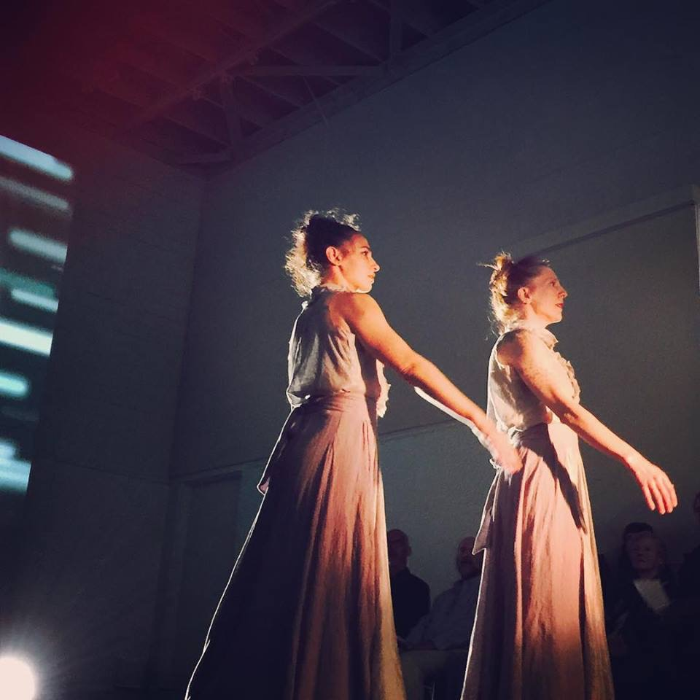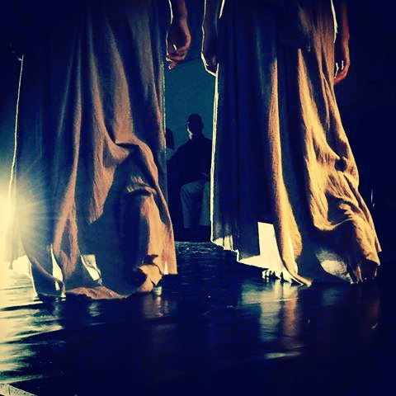
Figure 3a/b. ‘Flocking’ Curio. Photo credit: Kecya Felix Donnelly, 2015.

Other curio visualizations introduce a kind of visual latency that amplifies the rhythm and duration of breath. For example, one appears like a ‘frequency blanket’ in which data moves the first point, and then travels sequentially, like an electrocardiogram, except that the lines are multiplied, offset, and shifted in 3-dimensional space (Figure 4). With magnitudes of breath producing various flows, the dancers can play games where, once we stop moving, we have to hold our breath until the visualization almost completely settles, before we are allowed to move again, or in which the two performers breathe in opposition to keep the blanket steady. In the ‘Settling Trio’ curio, this builds into a more complicated improvisational feedback loop: Nicely, wearing a sensor, sets up a settling game, in which she moves for the length of a long exhalation, then suspends movement and breath to wait for the visualization to settle before exhaling another sequence of movement. After she establishes this pattern, I enter at the end farthest from the projection and Nicely turns to face me. The rest of the curio extends the duet into a trio: Nicely trails my movement, which is directed by a score based on me watching the visualization of her breath animate and settle, as she watches and follows my movement that plays the game now with her breath, producing, in turn, further chains of movement. The settling game already introduces a time-shift, and the refraction through an additional breathing body extends that cycle further.
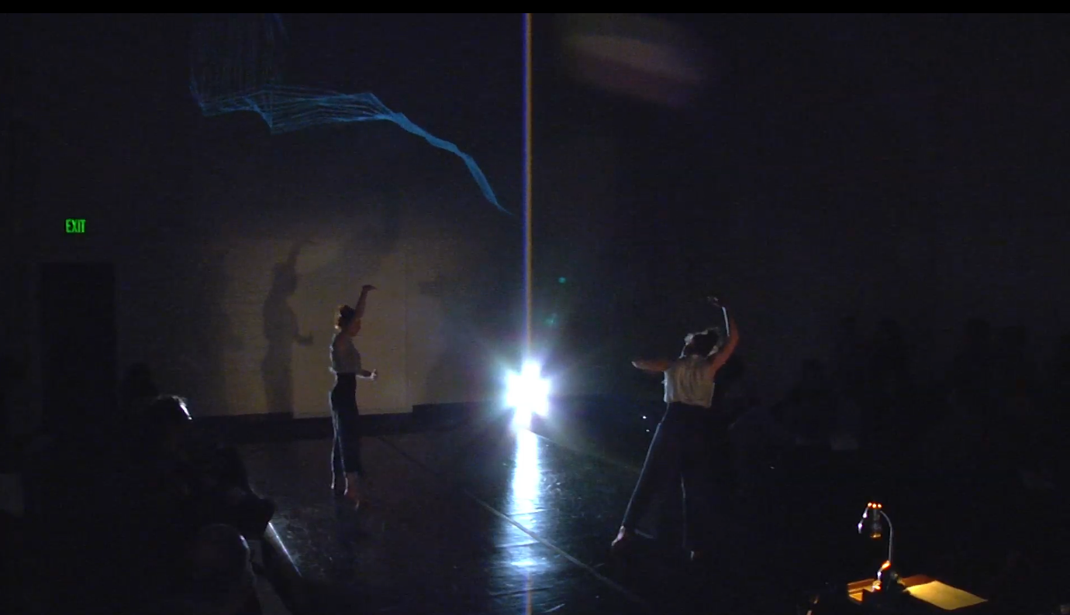
Figure 4. ‘Settling Trio’ Curio. Screengrab from video documentation by Loren Robertson, 2015.

While the previous examples are about live feedback, we also explore different means to save and re-use the breath sensor data. The ‘Breath Sculptures’ curio is about scaling breath. It is built with an additive visualization that begins entirely as a blank projection, but fills up to a light blue over the course of the scene, through the accumulation of individual blue eyedropper dots that are mapped from my live breath being collected during this curio and, remixed with Nicely’s saved breath from the previous curio. The collecting and mixing of present and past data, ultimately rescales the breathing; in this scene, our movement is sparse, cycling through a series of poses with long sculptural holds during which the only movement was that produced by steady inhalation and exhalation, but the accumulated breath through it is enough to create and change an immersive environment.
Processes of collection and re-accessing extend to other breath media, including audio recording. The ‘Wall Pant’ curio is based on rhythmic exhale produced by slamming your back into the wall, which changes the feeling of volume in the body (Figure 5). The choreography is repetitive but evolves over the three and a half minutes, with every exhale as one impact and one movement cycle. From a dramaturgical standpoint, this action highlights how movement of the body can overwhelm the movement of breath — in this particular moment, the thump of our bodies against the wall is often louder than the exhalation it produces. So our composer, Davis, had us perform to a modified recording of our breath from previously doing the exact choreography, on top of which he and violist Stephanie Griffin then layered a track that imagined the upbow and downbow strokes of the viola as the instrumentalist breathing with us. In live performance, we then play back that recording, and time our movement, so that the present breath is synchronized with the past. In reactivating the relationship between present and past breath, we call attention to the breath task as a non-naturalistic modality that is used to access specific dimensions of breathing. There is also a second version of this curio, in which the audience only sees us when we are inhaling, because we are lit by a projection tied to our breath sensors that dims when we exhale and becomes brighter the deeper we inhale; it creates a flickering world that kind of catches us in freeze frame, but also reinforces just how many breaths fill three and a half minutes. Although the ‘Wall Pant’ curios came first from the very particular breath quality of using impact to produce exhalation, audiences tend to describe the rhythmic duet (or, with the recording, quartet or quintet) back to us in terms of attraction and isolation.

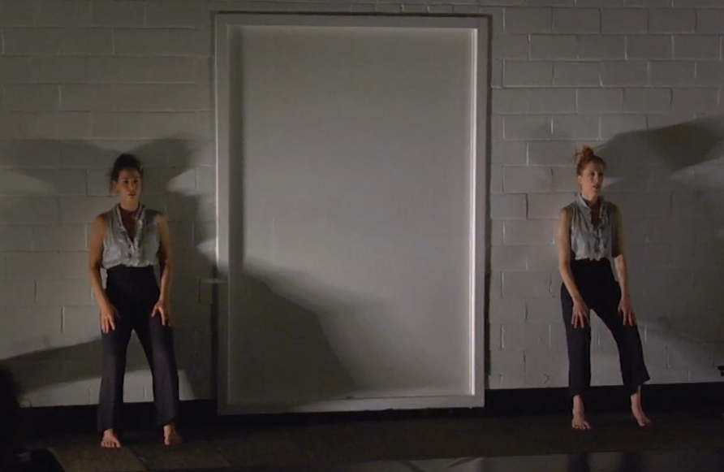
Figure 5. ‘Wall Pant’ Curio. Screengrab from video documentation by Loren Robertson, 2015.

We also work with developing sensory experiences through the reembodiment of found cultural artifacts of breath, such as in a curio based on the late sci-fi noir film Kiss Me Deadly. We had started watching old film noirs because of the heavy breathing in them. But when we shut off the sound, the actors’ bodies did not reflect that intensity of respiration, or even show any visible breath. In response, we developed a kind of ‘Breath Karaoke’ practice that uses live performance, together with a hand-held projector to return the physicality of the breath to the film. It draws on the breath patterns of the film’s audio track, and the actions that are supposed to produce them, while also remaking them into a collection of noir tropes that play with visibility and invisibility. The characters and scenes re-accessed through this archive in turn offer another means to share breath between ourselves and with audiences. In the first half, we project on the walls, floor, and one another’s bodies as we use poses and quick transitions to frame aspects of the film’s opening scene. As the credits come in and with them, Nat King Cole’s ‘Rather Have the Blues,’ we layer the breath track of the opening back over, and also add new live layers as well, first produced from a spacey slow-dance with no partner, then an exaggerated form of actress Marianne Carr’s strange run in which the lower arms flap from side to side at the elbow while the knees kick back, and finally a crime scene body-tracing. Beyond the breath track in itself and the ways in which its reanimation undergirds a particular investigation of gender and breath for this curio, Kiss Me Deadly has resonances for the Breath Catalogue project of curious collection more broadly, as a kind of late sci-fi noir that is in fact based around a mysterious object in a Pandora’s box (‘the great whatsit’).
In later iterations of Breath Catalogue, we began to explore fabricating performance objects, capable of visualizing the breath data in 3D, interactive form. In terms of materializing the breath, one inspiration was a tiny puff of smoke that is emitted from the dancer’s sternum each time she exhales, so that she can perform duets with the traces that her breath leaves in space. Following on the ideas of scaling, another was a kind of architecture in which the breath of the dancer could control a giant bellows onstage that breathes with her, or maybe the audience’s amalgamated breathing animates such an environment. We experimented with a variety of kinetic sculptures in the studio, but struggled to either synchronize or play against the underlying fans that were being turned on and off automatically by our breath, among other things because of the graduated time it took for them to spin up in response to any change. The only breath object that made it onstage was the ‘Breath Jar’ that Gimpert and I built for the 2016 UK performances from a palm-sized jam jar with some LEDs, feathers, and a microcontroller inside. In performance, I would stand in front of an audience member and breathe, and from close range, the shades of blue inside the jar would deepen and lighten in a direct relationship to me, and then I would hand off the breath jar to them to first hold and then pass along through the audience, entrusting my breath to move into and circulate through the care of others.

Beyond the Theatre

Early on, I introduced the many dimensions of breath’s palpability, as well as the challenges of collecting and sharing breath experiences both in themselves and in tandem with breath media. These concerns inform the Breath Catalogue at the same time as they extend questions and problems that arose in the studio and the conversations surrounding the practice of building a living cabinet of breath curiosities more broadly. One question that lingers is the nature of watching breath. Although we build a small cabinet installation in theatre entryways for audiences to engage with various dimensions of their breath through sensory tasks (Figure 6), Breath Catalogue is not an audience participation show. Instead, under the guiding project of palpability, we invite the audience to engage with their own breath expertise or at least curiosity through our performance as dancers who are already what medical anthropologists would term ‘expert breathers,’ and whose skills in that area have been further amplified by the demands of the specific practice.
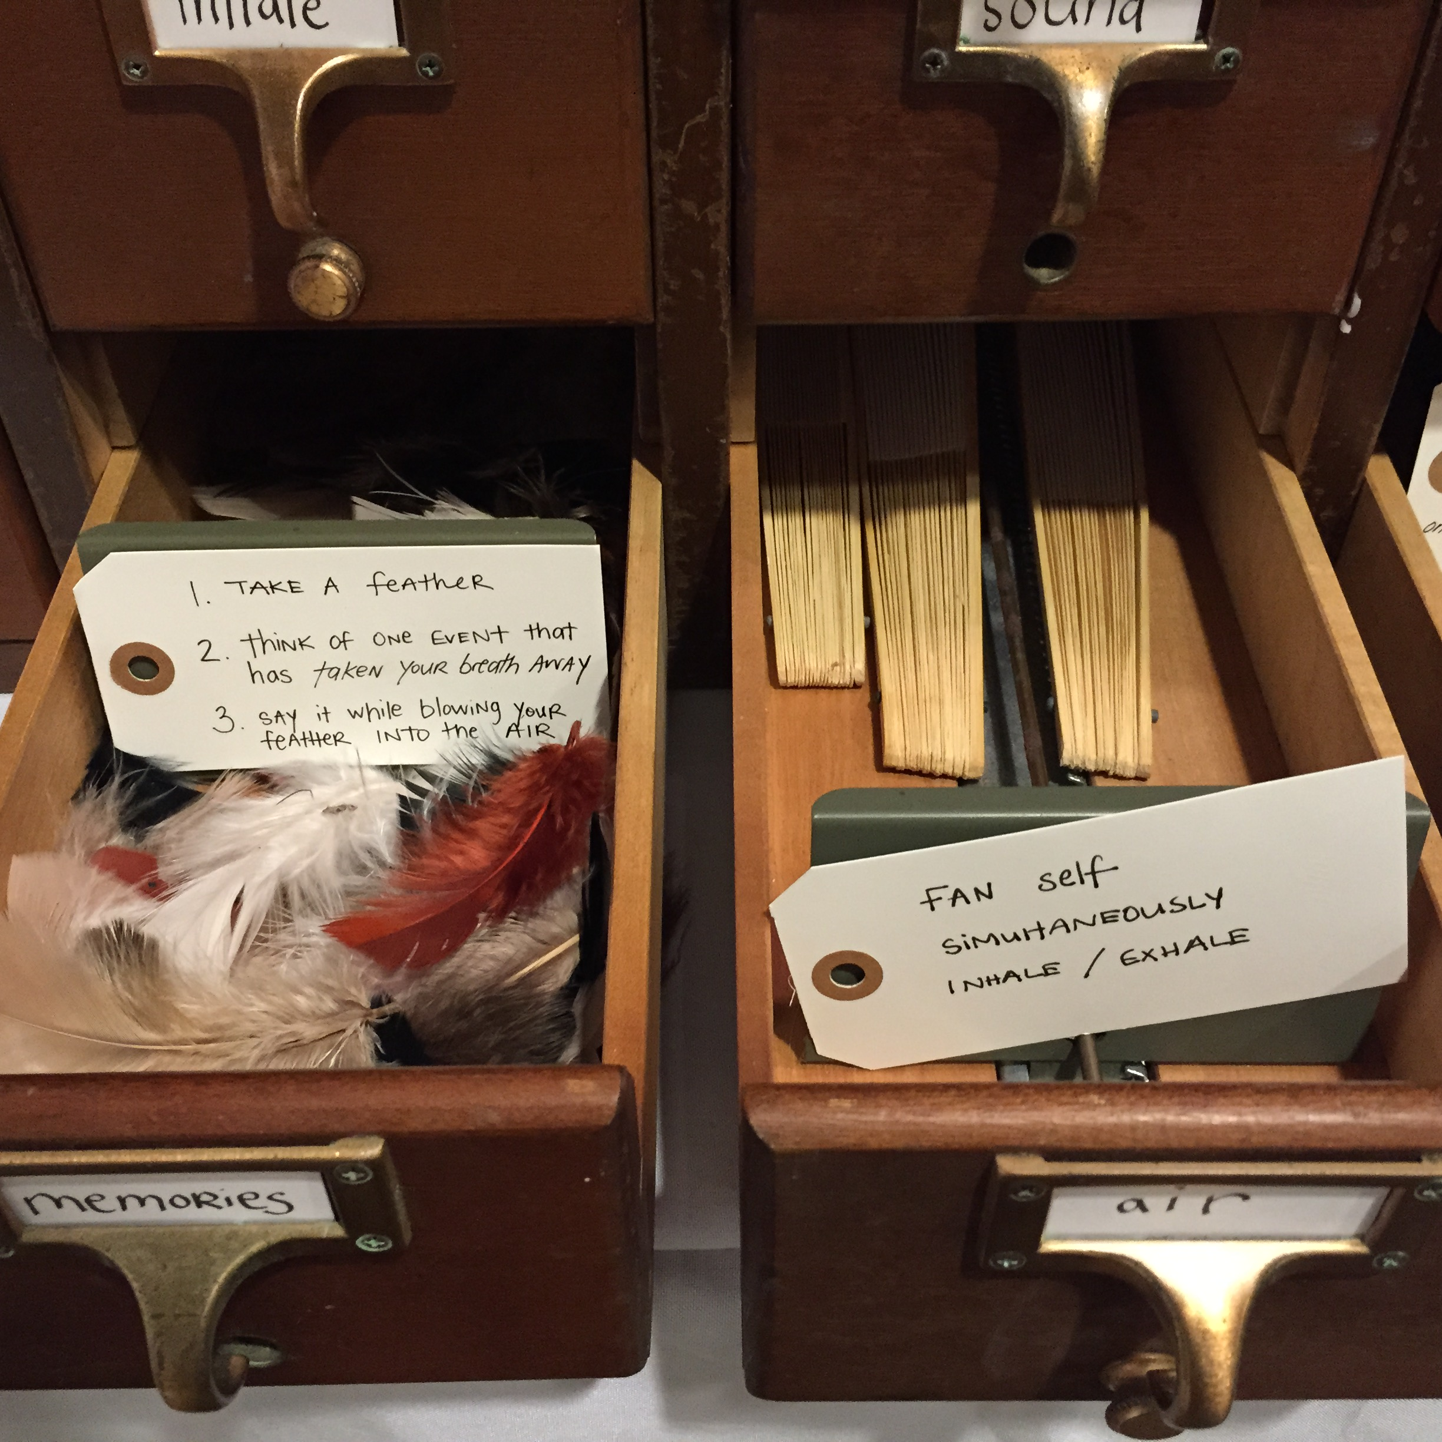
Figure 6. Cabinet of Breath Curiosities Installation.
We discovered that, after we dance for an hour with this hyper-choreographed, intersubjective approach to our breath, everyone wants to talk to us about their breath. Many audience members describe holding their breath with us in various curios, or suddenly discovering that they had tuned into our patterns of inhalation and exhalation — at times producing pleasure and at others anxiety. They seem to want to share their own experiences and memories as well; when we asked audiences during one show to leave us a note afterwards with something they experienced or discovered about breath, we had over a 50% response rate. When I told this to a gathering of doctors, nurses, and technicians at the North Bristol Lung Centre, they were shocked, because of how difficult it can be to discuss breath experiences. I had seen this too; most patients I observed not only lacked a robust language to describe their breath experiences, but in fact many ‘presented’ with increased difficulty when they turned their attention to describing their symptoms.
One of the things that struck me in the hospital residency was how much time was spent during initial screenings speaking to patients in making decisions for onward referrals, and the way this interacted with the modest time involved in direct examination. When I asked, one of the doctors told me that the part at the end in which he got out his stethoscope and they took off their shirts was sometimes more for their benefit than his. Rather, his preliminary diagnosis had often already come from the qualitative language of their descriptions, as well as what he observed in their bodies and breathing as they spoke to him. His point that most patients would not trust that appraisal if they did not feel ‘examined’ recalls a 1946 debate around the role of the stethoscope (Reiser 1978, 169). The promise of making breath palpable through a cabinet of breath curiosities in performance likewise works to expand the methods we use to catalogue sensory experience, tapping into the extreme permeability of breath in the sense of the intimate and physical connections that it builds, at the same time as grappling with trust in terms of the challenges of making such multidimensional experiences perceptible to others. It is in this sense that I describe Breath Catalogue as engaging with the capacity of performance as a laboratory in which to explore new means of cataloguing the particularity of breath experiences through, rather than despite, the paradox of breath’s permeability and un-shareability.
At the end of Numbered Lives, Wernimont makes an argument for the need to ‘count otherwise’ in thinking about life and death in quantum media. Although she never deals with breath directly, her advocacy for returning remediated data to bodies and thereby creating ‘media that allow us to engage the messiness of life and death’ is resonant (2018, 163). Over the past few decades, performance practices have tended away from engaging with breath data because of the complications of its capture. However, this is precisely where we are best trained as scholar-artists to work: to deal with such messiness as opportunity to undo the authority of the overdetermined mapping between biodata and lived experience, to instead lean into the partial and uncertain nature of performative measure, and in so doing to pose new prompts to our own somatic and biofeedback practices that model ways in which breath might become shareable, differently.

Bench, Harmony. 2016. “Dancing in Digital Archives: Circulation, Performance, Pedagogy.” In Transmission in Motion: The Technologizing of Dance, edited by Maaike Bleeker, 155–67. London: Routledge.
Birringer, Johannes. 2008. Performance, Technology, and Science. New York: PAJ Publications.
Bleeker, Maaike. 2010. “Corporeal Literacy: New Modes of Embodied Interaction in Digital Culture.” In Mapping Intermediality in Performance, edited by Sarah Bay-Cheng, Andy Lavender, Chiel Kattenbelt, and Robin Nelson, 38–43. Amsterdam: Amsterdam University Press.
Blum, Alan. 2011. The Grey Zone in Health and Illness. Bristol: Intellect Books.
Braun, Lundy. 2014. Breathing Race into the Machine: The Surprising Career of the Spirometer from Plantation to Genetics. http://site.ebrary.com/id/10841143.
Calais-Germain, Blandine. 2006. Anatomy of Breathing. Seattle, WA: Eastland Press.
Carel, Havi. 2016. Phenomenology of Illness. Oxford: Oxford University Press.
Carel, Havi, and Jane Macnaughton. 2016. “Breathing and Breathlessness in Clinic and Culture: Using Critical Medical Humanities to Bridge an Epistemic Gap.” In The Edinburgh Companion to the Critical Medical Humanities, edited by Anne Whitehead and Angela Woods, 294–309. Edinburgh: Edinburgh University Press. https://www.ncbi.nlm.nih.gov/books/NBK379257/.
Carel, Havi, Jane Macnaughton, and James Dodd. 2015. “Invisible Suffering: Breathlessness in and Beyond the Clinic.” The Lancet Respiratory Medicine 3 (4): 278–79. https://doi.org/10.1016/S2213-2600(15)00115-0.
Cohen, Julie E. 2016. “The Surveillance-Innovation Complex: The Irony of the Participatory Turn.” In The Participatory Condition in the Digital Age, edited by Darin David Barney, E. Gabriella Coleman, Christine Ross, Jonathan Sterne, and Tamar Tembeck, 207–26. Electronic Mediations 51. Minneapolis London: University of Minnesota Press.
Connor, Steven. 2010. The Matter of Air: Science and the Art of the Ethereal. London: Reaktion Books.
Crawford, Kate, Tero Karppi, and Jessa Lingel. 2015. “Our Metrics, Ourselves: A Hundred Years of Self-Tracking from the Weight Scale to the Wrist Wearable Device.” European Journal of Cultural Studies 18 (4–5): 479–496.
Crawley, Ashon T. 2017. Blackpentecostal Breath: The Aesthetics of Possibility. First edition. Commonalities. New York: Fordham University Press.
Davenne, Christine. 2012. Cabinets of Wonder: A Passion for Collecting. New York: Abrams.
Davidson, Andrea. 2016. “Ontological Shifts: Multi-sensorality and Embodiment in a Third Wave of Digital Interfaces.” Journal of Dance and Somatic Practices 8(1): 21–42.
Davies, Char. 2018. Interview with the Author.
DeFrantz, Thomas. 2012. “Unchecked Popularity: Neoliberal Circulations of Black Social Dance.” In Neoliberalism and Global Theatres: Performance Permutations, edited by Lara Nielsen and Patricia Ybarra, 128–42. New York: Palgrave Macmillan.
deLahunta, Scott. 2002. “Periodic Convergences: Dance and Computers.” In Tanz und Technologie: auf dem Weg zu medialen Inszenierungen = Dance and technology: moving towards media productions, edited by Söke Dinkla and Martina Leeker, 66–84. Berlin: Alexander.
Dixon Steve. 2007. Digital Performance: A History of New Media in Theater, Dance, Performance Art, and Installation. Leonardo. Cambridge, Mass: MIT Press.

Drucker, Johanna. 2011. “Humanities Approaches to Graphical Display.” Digital Humanities Quarterly 5 (1).
Eccleston, Christopher. 2016. Embodied: The Psychology of Physical Sensation. First edition. Oxford, United Kingdom: Oxford University Press.
Elswit, Kate. forthcoming. “Performative Measure.” In Uncertain Archives. Cambridge: MIT Press.
———. 2014a. “Inheriting Dance’s Alternative Histories: Dramaturg’s Notes on Future Memory.” Dance Research Journal 54 (1): 3–22. https://doi.org/10.1017/S0149767714000151.
———. 2014b. “Using Spire in Dance Choreography, Part I.” The Spire Wellness Blog (blog). September 2, 2014. https://blog.spire.io/2014/09/02/using-spire-in-dance-choreography-part-1/.
———. 2015. “Choreographing with Spire, Part 2.” Breath Catalogue (blog). May 11, 2015. https://www.breathcatalogue.org/choreographing-with-spire-part-2/.
Faull, Olivia K., Lucy Marlow, Sarah L. Finnegan, and Kyle T.S. Pattinson. 2018. “Chronic Breathlessness: Re-Thinking the Symptom.” European Respiratory Journal 51 (1): 1702238. https://doi.org/10.1183/13993003.02238-2017.
Fitting, Jean-William. 2015. “From Breathing to Respiration.” Respiration 89 (1): 82–87. https://doi.org/10.1159/000369474.
Forsythe, William. n.d. “Choreographic Objects.” Synchronous Objects for One Flat Thing, Reproduced. https://synchronousobjects.osu.edu/media/inside.php?p=essay.
Foster, Susan Leigh. 2010. Choreographing Empathy: Kinesthesia in Performance. New York: Routledge.
Franko, Mark, ed. 2017. The Oxford Handbook of Dance and Reenactment. Vol. 1. Oxford University Press. https://doi.org/10.1093/oxfordhb/9780199314201.001.0001.
Gimpert, Ben. 2015. “Ben Gimpert Talks Science and Art in Collaborative Performance Piece ‘Breath Catalogue.’” SciArt Magazine. September 29, 2015. https://www.sciartmagazine.com/blog/intereview-talks-science-and-art-in-collaborative-performance-piece-breath-catalogue.
Górska, Magdalena. 2016. Breathing Matters: Feminist Intersectional Politics of Vulnerability.
Goudouna, Sozita. 2018. Beckett’s Breath: Anti-Theatricality and the Visual Arts. Edinburgh Critical Studies in Modernism, Drama and Performance. Edinburgh: Edinburgh University Press.
Hayen, Anja, Mari Herigstad, and Kyle T.S. Pattinson. 2013. “Understanding Dyspnea as a Complex Individual Experience.” Maturitas 76 (1): 45–50. https://doi.org/10.1016/j.maturitas.2013.06.005.
Irigaray, Luce. 1999. The Forgetting of Air in Martin Heidegger. 1st ed. Constructs Series. Austin: University of Texas Press.
Karreman, Laura. 2017. “The Motion Capture Imaginary: Digital Renderings of Dance Knowledge.” Ghent University.
Klingan, Katrin, ed. 2015. Textures of the Anthropocene: Grain, Vapor, Ray. Cambridge, MA: The MIT Press.
Kozel, Susan. 2007. Closer: Performance, Technologies, Phenomenology. Cambridge: MIT Press.
Kuppers, Petra. 2007. The Scar of Visibility: Medical Performances and Contemporary Art. Minneapolis: University of Minnesota Press.
Kuriyama, Shigehisa. 2011. The Expressiveness of the Body and the Divergence of Greek and Chinese Medicine. 1. paperback ed., 4. print. New York: Zone Books.
Lukkas, Lynn Tjernan. 2018. Interview with the Author.
Lupton, Deborah. 2013. “Quantifying the Body: Monitoring and Measuring Health in the Age of MHealth Technologies.” Critical Public Health 23 (4): 393–403. https://doi.org/10.1080/09581596.2013.794931.
Magnet, Shoshana Amielle. 2011. When Biometrics Fail: Gender, Race, and the Technology of Identity. Durham, N.C.: Duke University Press.
Mauriès, Patrick. 2011. Cabinets of Curiosities. New York: Thames & Hudson.
Metzl, Jonathan, and Anna Rutherford Kirkland, eds. 2010. Against Health: How Health Became the New Morality. Biopolitics, Medicine, Technoscience, and Health in the 21st Century. New York: New York University Press.
Morrison, Elise. 2016. Discipline and Desire: Surveillance Technologies in Performance. Ann Arbor: University of Michigan Press.
Naccarato, Teoma and John MacCallum. 2016. “From Representation to Relationality: Bodies, Biosensors and Mediated Environments.” Journal of Dance and Somatic Practices 8(1): 57–72.
Nicely, Megan V. 2017. “Animation Project: Activating Life at the Periphery.” Choreographic Practices 8 (2): 311–31. https://doi.org/10.1386/chor.8.2.311_1.
Picard, Rosalind W. 1997. Affective Computing. Cambridge, Mass: MIT Press.
Reiser, Stanley Joel. 1978. Medicine and the Reign of Technology. Cambridge ; New York: Cambridge University Press.
Salter Chris. 2010. Entangled: Technology and the Transformation of Performance. Cambridge, Mass: MIT Press.
Samudra, Jaida Kim. 2008. “Memory in Our Body: Thick Participation and the Translation of Kinesthetic Experience.” American Ethnologist 35 (4): 665–81. https://doi.org/10.1111/j.1548-1425.2008.00104.x.
Schiphorst, Thecla. 2009. “Body Matters: The Palpability of Invisible Computing.” Leonardo 42 (3): 225–30.
Schneider, Rebecca. 2001. “Performance Remains.” Performance Research 6 (2): 100–108.
———. 2018. “Slough Media.” In Remain, edited by Ioana B. Jucan, Jussi Parikka, and Rebecca Schneider, 49–107. In Search of Media. Minneapolis: University of Minnesota Press.
Schramm, Helmar, Ludger Schwarte, and Jan Lazardzig, eds. 2005. Collection, Laboratory, Theater: Scenes of Knowledge in the 17th Century. Theatrum Scientiarum, v. 1. Berlin ; New York: Walter de Gruyter.
Schüll, Natasha Dow. 2016. “Data for Life: Wearable Technology and the Design of Self-Care.” BioSocieties 11 (3): 317–33. https://doi.org/10.1057/biosoc.2015.47.
Sharon, Tamar, and Dorien Zandbergen. 2017. “From Data Fetishism to Quantifying Selves: Self-Tracking Practices and the Other Values of Data.” New Media & Society 19 (11): 1695–1709. https://doi.org/10.1177/1461444816636090.
Wernimont, Jacqueline. 2018. Numbered Lives: Life and Death in Quantum Media. Media Origins. Cambridge, MA: The MIT Press.
Whatley, Sarah. 2013. “Siobhan Davies RePlay: (Re)Visiting the Digital Archive.” International Journal of Performance Arts & Digital Media 9 (1): 83–98. https://doi.org/10.1386/padm.9.1.83_1.
Whitson, Jennifer R. 2013. “Gaming the Quantified Self.” Surveillance & Society 11 (1/2): 163–76. https://doi.org/10.24908/ss.v11i1/2.4454.
Williams, Marie, Paul Cafarella, Timothy Olds, John Petkov, and Peter Frith. 2008. “The Language of Breathlessness Differentiates Between Patients With COPD and Age-Matched Adults.” Chest 134 (3): 489–96. https://doi.org/10.1378/chest.07-2916.

On the theatricality of this form of knowledge, see Schramm, Schwarte, and Lazardzig (2005)
Although I was not named in the successful Wellcome Trust application for Life of Breath in 2014, my work on Breath Catalogue led me to join as a researcher.
John Hutchinson’s 1840s consolidation and naming of the spirometer, and with it a science of measuring ‘vital capacity,’ used numerical measurements of physiological operations at scale to establish a benchmark for the normal body and situate the individual in relation to it (Reiser 1978, 91–95; Braun 2014).
‘Performative Measure: Tracking Breath Bodies in Biodata and Performance’ (under review). See also 'Performative Measure,' forthcoming.
The theatrical performance is configured as a runway, two Marleys wide, with audience seating on tiers of chairs and stools along the length. At one end is a wall, and at the other a table with a small library catalogue illuminated by a lamp at the other, behind which is our tech configuration. While some projections move through space, many are located high on the wall, at times reflecting onto the performers, at others forcing audience members to make choices between the bodies and the visualizations created from their data. The site-specific performance on the farm was timed to sequence through different locations—a garden, a greenhouse, the stairway to a cottage, a shed—as the sun went down.
Nicely and I had collaborated previously on new materialist strategies for decentering the human onstage in Animation Project (2010-12) (see Nicely 2017); with Breath Catalogue we turn specifically to the ways in which such strategies might be applied and extended through a close engagement with breathing.
Potions of the track and detailed audio description of sections of the choreography is available on the BBC Radio 4 series The Rhythm of Life, ‘The Symphony Within,’ first aired 21 August 2018, https://www.bbc.co.uk/programmes/b0bfy970.

