Intergenerational Process Drama: Practitioner Reflection on Creative Adventures in an acute hospital context.
Dr Nicola Abraham, Royal Central School of Speech and Drama UK, Jo James, Imperial College Healthcare NHS Trust, Dr Elizabeth McGeorge, Imperial College Healthcare NHS Trust.
Abstract:
This reflection will offer insights into the methodology of process drama as a tool for intergenerational connection, co-intentional pedagogy and playfulness for children collaborating with older adult patients living with dementia. Providing insights into the adaption of conventional models of process drama drawing on the work of Cecily O’Neill, this reflection considers the key lessons learnt from two years of Intergen, a project funded by Imperial Health Charity. Though the project itself incorporated multiple art forms, this piece will focus on intergenerational process drama to share insights into the way the practice evolved to engage both older adult patients and children in acute hospital contexts.
Introduction
Over the past two years, we have developed a collaborative intergenerational project and practice responding to acute hospital settings in partnership with the Dementia Care Team and Paediatric department at Imperial College Healthcare NHS Trust and Connecting Care for Children (CC4C). The NHS is a national health service in the UK offering free healthcare for everyone. The intergenerational was project located in NHS hospitals and involved five primary schools (130 children), and two hospitals in London, UK (working with approximately 180 patients) between 2017-2020. The intention of the project is to build intergenerational connections between older adult patients, predominantly people living with dementia to improve wellbeing and offer cognitively stimulating activities, and school children to address preconceptions of ageing, dementia and negative constructs of hospital. Though the project has offered a number of different interventions including art and gallery collection workshops from the Wallace Collection, community choir sessions from Starling Arts, puppetry making and animation from Mary Klaber, storytelling from Gaynor Smith, art and creativity from Paperbirds’ practitioner Marenka Gabeler, interactions with city farm animals, and many more events, the purpose of this article is to focus on the development of intergenerational Process Drama sessions created for this project.
Intergenerational Pedagogy for Process Drama
Process Drama is in essence a flexible methodology for collaborative storytelling that intentionally invites a responsive pedagogical approach to enable groups to engage and take ownership of an experiential narrative. Cecily O’Neill (1995) conceived of the form as follows: “Process [D]rama involves the making, shaping, and appreciating a dramatic event, an experience that articulates experience. Participants control significant aspects of what is taking place; they simultaneously experience it, and organize it; they evaluate what is happening and make connections with other experiences” (ibid, 1). It is this ‘shared’ sense of ownership that is important in intergenerational interactions to build connections between participants. In this case though, the participant group were not, as traditionally noted, primary school children in a classroom, they were older adult patients aged 65yrs +, children, nurses, facilitators-in-role, and dementia care team staff in an acute hospital context (see image 1).
Image 1: ‘Defenders of the Universe’ Process Drama Session.
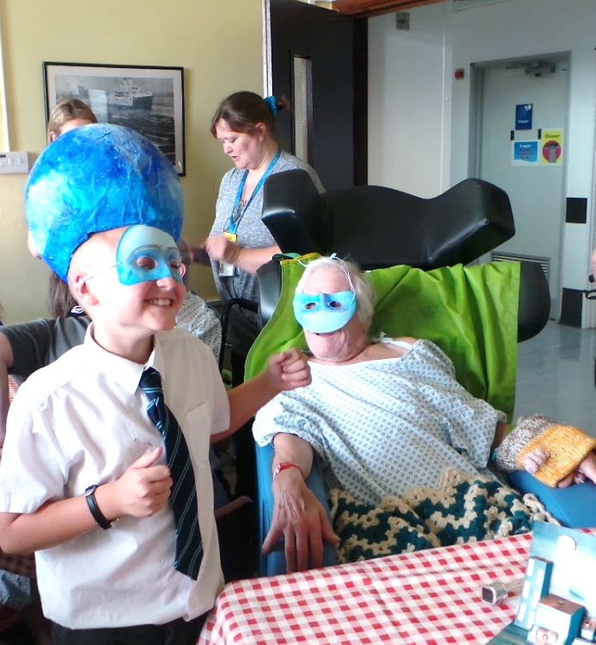
[Photograph by Dementia Care Team]
In total, we created five intergenerational Process Drama sessions that were accessed by all five schools who took part in the project between 2017-2020. The themes of the Process Drama sessions were designed to capture interests for patients (usually aged 65yrs+) and children (age 6-11yrs). The themes of the Process Dramas ranged from renewable energy, time travel, portals, mysterious manor house adventures, Woodland Fairies and Stars, and Christmas. The renewable energy session will be discussed in more detail later in this article, and explored the Beta quadrant of space with participants in role as intergenerational heroes ‘Defenders of the Universe’, who were on a mission to save four planets from the evil Lord Trum-Petty who had stolen a renewable energy device, which the participants had to locate and return. The time travel adventure moved through all the other worlds of the Process Dramas in this project to locate a rogue time traveller who wanted to disrupt the timeline for his own gain. The participants were in role as time travellers with expert knowledge of each of the worlds they travelled to, and had to find the rogue time traveller before he caused trouble by changing the timeline. The Portals project draws upon the important historical figure, Katherine Johnson, an American mathematician whose calculations were pivotal for NASA’s first and subsequent space flights. The story retraced her history through a fictional frame where participants were explorers and had to solve puzzles to prove their own skills in solving problems to locate accounts of Katherine Johnson’s life and history. The mysterious manor house Process Drama presented a narrative for Halloween, but couldn’t be about ghost stories or death because this wouldn’t be appropriate given the context of the hospital, so it was created to offer a mystery for the group, in role as detectives to solve together when strange events kept happening at a very old local hotel in a small village in the countryside. The woodland based Process Drama titled Ancient Oak, Fallen Star, told the incomplete story of a star that was curious about humans and watched over them and the magical world. However, one day in the process of looking too closely whilst trying to provide light for characters in trouble in a dark woodland, was caught in earth’s gravity and fell to the ground. The Elvan queen whose life was saved by the Star’s light, transformed the star into an ancient oak to protect it until it could return to the sky. The participants are in role as magical beings who help the star return to the sky through completing a series of mini quests. The Christmas Process Drama asked participants in-role as elves to help an character who had just been promoted to Head Elf to retrieve a set of narratives they had lost from Santa’s storybook. Each of the stories places emphasis on teamwork, collaborative imagination, play and storytelling.
Patients who took part in the project were chosen by the Dementia Care Team, a specialist clinical team who promote dementia awareness and understanding across Imperial College Healthcare NHS Trust hospitals. Patients were consented in the morning and again in the afternoon to see who would like to take part and had to pass infection control to participate. There was deliberately not a strict age selection criteria, though the project took place predominantly in medicine for the elderly wards and those living with dementia and known to the Dementia Care Team to support them during their stay in hospital. For the schools, teachers were given autonomy to choose children they felt would benefit from taking part in the project. This often included children who experienced anxiety at school or low confidence in the classroom, and children with a range of learning differences including ADHD, elective mutism, and Asperger’s Syndrome.
Part of the rationale for using Process Drama in this context connects to the need to alleviate the day to day boredom often experienced by patients living with dementia. Jo James et al. (2017) note that boredom experienced by patients can lead to “a decline in social functioning… Often wards have no social space, which results in patients being kept at their bedside or in bed for long periods of time and in many cases not knowing the reason they are there, increasing the likelihood of boredom, aggression and withdrawal” (ibid., 144). James et al. continue by proposing the importance of engagement with activities to enable patients to express emotions, increase social interaction, feel a sense of belonging, and feel valued (ibid.). These feelings and experiences are vital to ensure patients feel that they matter, and their personhood is respected. In Process Dramas, everyone has a duty to play to maintain the magic of the liminal space for the duration of the workshop. Unlike conventional Process Dramas that may stop and allow participants to step out of the fictional realm to reflect on their decisions, the Process Dramas that we created for acute hospital contexts didn’t have the luxury of time and stepping in and out of frame may have caused confusion, frustration and upset for patients. Therefore, creating immersive spaces and transforming day rooms with projection, augmented reality, props, costumes, and music was essential to create safe spaces for patients and children to engage in playful narratives together. These elements changed the expectations of patients and children entering day room spaces as they encountered what Pamela Bowell and Brian Heap (2013) term the signs of the world, “that bring meaning to the metaphor of the drama” (2013, 8-9). Providing signifiers of a fictional world creates intrigue for participants that invest a collective sense of wonder and opportunities for collaborative discovery within the fictional world. This draws everyone together in a neutral space that is deliberately playful, and full of opportunities to share in an adventure as a group.
Intergenerational practice is about creating connections between older adults and children through engaging interactions. Process Drama is a strategy for collective and collaborative exploration and draws upon the expertise of everyone in the workshop, thereby placing value upon the contributions of children and older adult patients in their responses to the mission dilemma presented in the fictional frame. For example, one session took participants on a space mission to save the Beta quadrant from environmental destruction caused by antagonist, Lord Trum-Petty, who stole renewable energy devices from the four planets in that part of space leaving civilisations in peril. Process Drama draws upon Dorothy Heathcote’s (1994) ‘mantle of the expert’ (MoE), a highly influential pedagogical and creative strategy that promotes dramatic inquiry, expert framing and drama for learning (Aitken, 2013, 36). It was the role of our participants, framed as expert scientists and heroes in training, to recover the lost device, help the planet locate Lord Trum-Petty and devise additional renewable energy resources from partly completed previous attempts made by the Planets’ scientific community, to save the worlds. A ritual was developed to enable both patients and children to step into role before the session began to note their current level of qualification as heroes in training, and to convey the mission briefing. This required layering pre-texts, which are the stimuli for the session that draw both groups into the world. The mission briefing prophecy document for this particular session was read and discussed one to one with patients before children arrived, and children were briefed as a group by the mission commander in role outside the ward so that when they entered the day room, they knew partly what to expect and also brought their energy of excitement with them to the mixed teams they worked with (see image 2).
Image 2: Mission Briefing Pre-Text 1
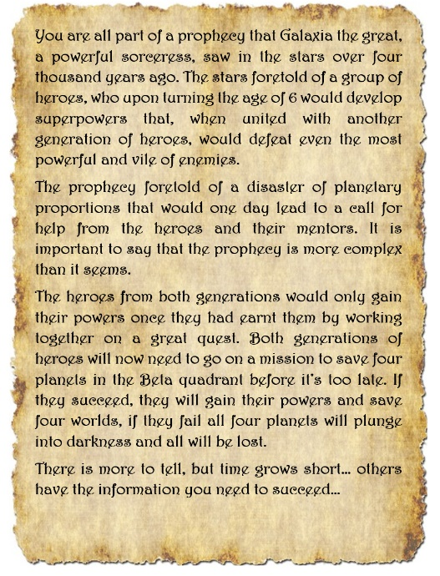
[Image created by Nicola Abraham, Intergen Project Team]
The participants then spent time developing group handshakes, and team names for their characters to create a group identity that was celebrated with the completion of each sub-mission throughout the course of the Process Drama. This encouraged initial dialogue between generations without the awkwardness that can arise from expecting children and patients to know what to say to one another. To boost confidence in the group, all children who took part in the project also receive drama based dementia awareness and communication strategy training before the workshops happened to ensure they have approaches to use and understand how to be responsive to the communication needs of the patients. The most important skill for responsive practice for all staff both medical and applied theatre facilitators was the ability to improvise and adapt to the ideas, direction, and contributions of the participants, which were often exciting and unpredictable. This divergent response led the Process Drama workshops in all kinds of directions as narratives developed and each team in the room supporting each planet experienced their own bespoke adventures. The improvisational nature of Process Drama provided a flexibility that allowed the form to shift, adapt and respond to the creative input of the participants. Bowell and Heap suggest that ‘[t]his is made possible through the human capacity for metaxis that enables us to say that we are both the makers of meaning and the receivers of meaning, simultaneously. Through our imagination… human beings have the capacity to inhabit two worlds at once’ (2017:10). This quality of the form meant that all suggestions could be both heard, played with and valued in the session, a key quality of developing feelings of achievement and self-worth for participants.
Though the form was flexible and enabled playfulness, there were other constraints we had to consider when adapting our practice. This space available was one of the main challenges in the sessions and the level of mobility for the patients meant that to ensure a safe and equal space was offered, teams were assigned in groups of 4-6 with 1-2 patients for every 3-4 children, in addition to two classroom teachers, a dementia care team specialist staff member for each patient and sub-team facilitators in role to offer high quality support for each group in addition to the lead facilitator, also in role. To help build intrigue and maintain participant interest in the sessions, we adopted the use of technology including avatars as interactive characters, and augmented reality maps to add in additional voices for characters in the session that we might in another space have in person in the room (see animation 1, 2 and image 3 for examples).
Animation 1: Secret information from Lord Trum-Petty
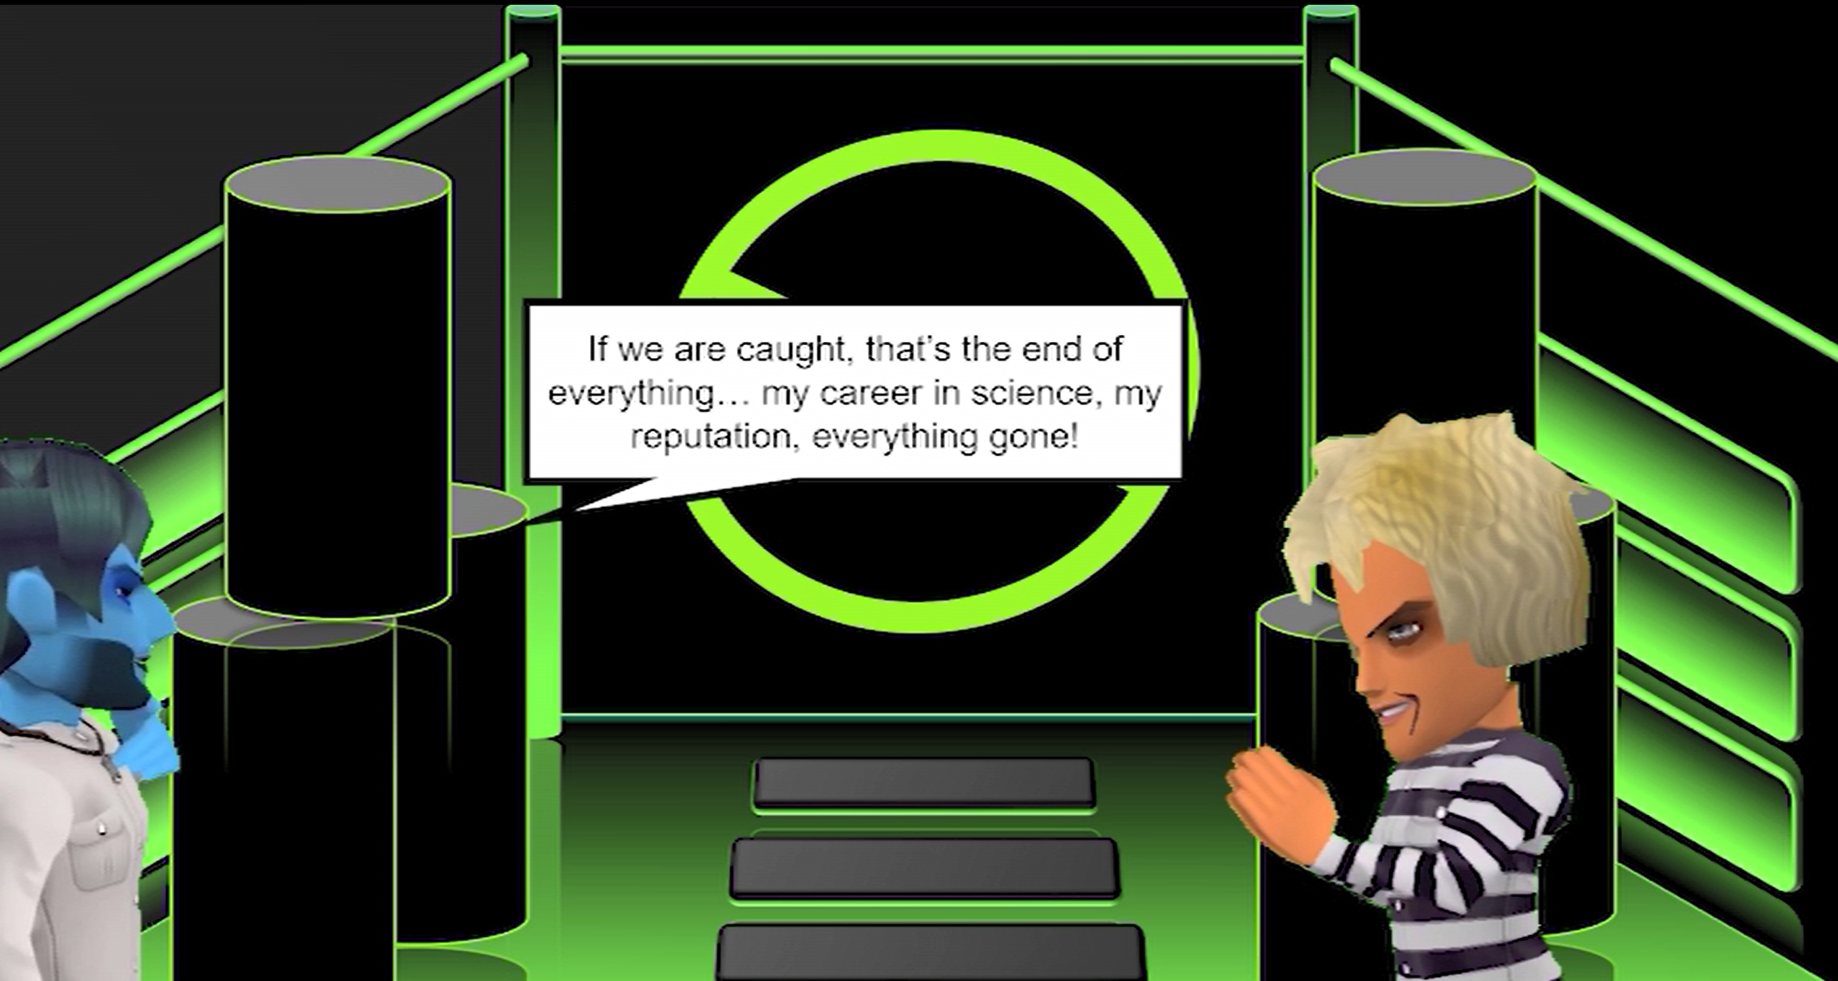
[Image created by Nicola Abraham, Intergen Project Team]
Animation 2: Mission Briefing from the ‘Commander’ with pauses for Teacher-in-role interactions live
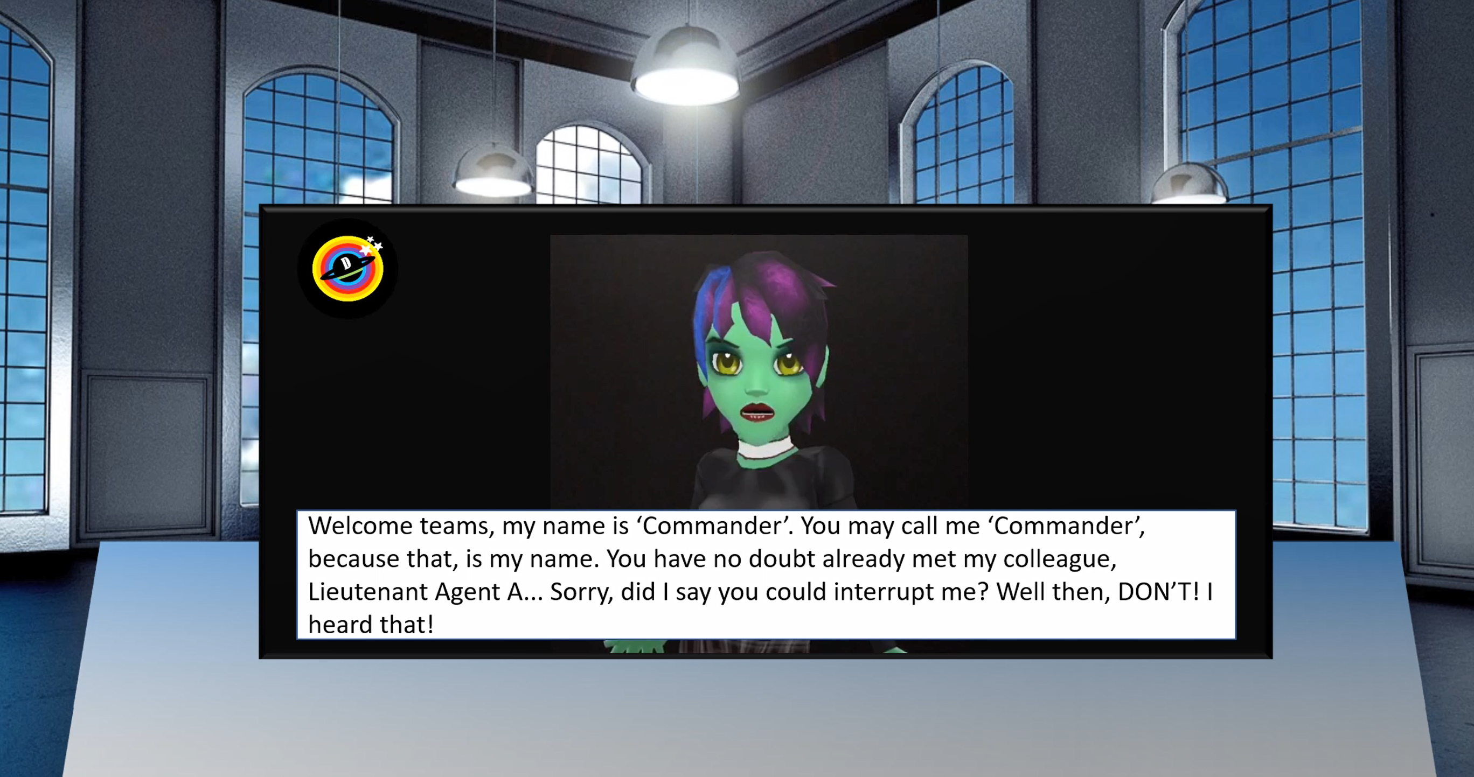
[Image created by Nicola Abraham, Intergen Project Team]

Image 3: Augmented Reality Map Character Voices
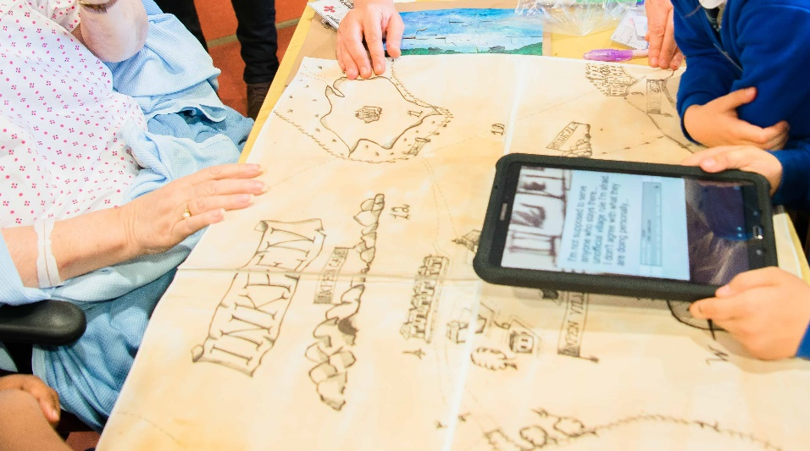
[Photograph by Akiko Dupont, Intergen Project Photographer]
The integration of technology to our Process Drama workshops meant that space was no longer a constraint because we found other ways to integrate immersive elements in the room. Projection and music were additional strategies we used to create the fictional world in addition to basic character costumes i.e. masks for participants, and full costumes for facilitators to bring the world to life and to engage in play. Play as a tool for intergenerational exchange meant that patients and children could develop co-intentional connections by learning form each other’s ideas and honour ideas by integrating them into their micro group narratives. This collaboration to complete a mission and reach a point of victory together meant that in a short space of time – usually between 60-90mins – an adventure had taken place and a collective achievement experienced between generations. Often patients reported back how intelligent they felt the children were, and children noted that their favourite part of the sessions were their interactions with the patients on their teams. Image 1 shows an example of this in action with two participants engaging in play wearing their masks, and rather less conventionally, the prop planet for the team as a hat! It was important to allow this moment to happen, it engaged the team in camaraderie and laughter together in a creatively playful moment. Reflecting upon the significance of creative interaction in dementia care, Jill Hayes (2011) draws upon the work of Carl Jung to explain the purpose of inventiveness: “[…] imagination rejoins us to the collective unconscious, a deep stratum of the human psyche, containing diverse archetypes which when reconciled and accepted create a mandala of wholeness and healing” (ibid.,40). In this case, participants’ engagement with the role of superheroes and exploring how to inhabit this frame led to a moment of shared joy and subversion of ‘expected’ way to engage with the costumes to suit the group’s interpretation of how they wanted to play and inhabit their team roles together. This moment may seem trivial but it transcends age and expectations about older adults expressed by the children in this particular session in their preparatory workshop on dementia where they were rather more fixated on what older adults couldn’t do which they associated with ageing, rather than what they could. This response to older adults is a construct of frailty, which in this moment of play, was challenged. The team dynamics required to engage with intergenerational process drama arguably create opportunities and permissions for playfulness between generations as they inhabit characters and share successes together in their own bespoke adventures. The immersive approach taken to this model of Process Drama means that participants don’t need to step in and out of frame, thereby retaining the options to explore and experiment with their characters, the props, costumes and narrative ideas without judgement or indeed to much emphasis on language – playfulness can indeed be in actions and not just words. This adds further layers of access and imagination for elective mute children and non-verbal older adult patients who have both taken part in our Process Drama workshops over the course of the project.
Concluding Thoughts
What we have learnt from this project is that it is vital to offer intergenerational exchange to happen in hospitals, the urgency of this need has only increased exponentially during the ongoing COVID-19 pandemic. Intergenerational connections are fraught around the world at present as a result of ageist responses to COVID-19 (Harris, 2020).. News reports note that younger generations feel they are being penalised for the vulnerability of older adults. Twitter posts worryingly blame older adults for lockdown, as a protection only for older people around the world. There are of course many cases of COVID-19 for younger age groups, and the illness has had, and continues to have a devastating effect across the world. These misconceptions and responses of blame are shaming of older populations and show a lack of value for the lives of older adults in our society. On the reverse, the International Psychogeriatric Association (IPA) reported the harrowing reality facing older adults who had underlying conditions and/or had to shelter to protect themselves from unnecessary exposure for the illness for many months (2020). The impact of fear, and long periods of social isolation has led to a decline in mental health and wellbeing for older adults and of course many other generations too. It is therefore vital to support older adults who face the prospect of being admitted to hospital at this point in time, which understandably may feel like the last place anyone would want to be. It is for this reason, and the learning we have been fortunate to gather over the past two years, that has led us to adopt digital technologies such as video calling and mira casting devices to allow us to continue with our intergenerational project this year between schools and hospital wards. Moments of joy, laughter and connection we hope will start to build bridges between generations, to offer discoveries of similarity to occur and above all to remind everyone involved of the value of our older adults.
Bibliography
Aitken, V. (2013). Dorothy Heathcote's Mantle of the Expert approach to teaching and learning: A brief introduction. In D. Fraser, V. Aitken, & B. Whyte (Eds.), Connecting Curriculum, Linking Learning (pp. 34-56), Wellington, New Zealand: NZCER Press.
Bowell, P. & B.S. Heap (2017) Putting process drama into action: the dynamics of practice. London: Routledge.
Harris, J. (2020) ‘Coronavirus has deepened prejudice against older people’, Guardian Online, available at: https://www.theguardian.com/commentisfree/2020/apr/26/prejudice-older-people-coronavirus [Accessed 20/10/20].
Hayes, J., & Povey, S. (2011) The Creative Arts in Dementia Care: Practical Person-Centred Approaches and Ideas, London: Jessica Kingsley Publishers.
Heathcote, D. & G. Bolton (1995) Drama for learning: Dorothy Heathcote's mantle of the expert approach to education. Portsmouth, NH: Heinemann.
IPA (2020) COVID-19, social distancing and its impact on social and mental health of the elderly population, Online Webinar, 23rd May 2020.
James, J., and B. Cotton, J. Knight, R. Freyne, J. Pettit, & L. Gilby (2017) Excellent Dementia Care in Hospitals: A Guide to Supporting People with Dementia and their Carers, London: Jessica Kingsley Publishers.
O'Neill, C. (1995) Drama worlds: a framework for process drama. Portsmouth, NH: Heinemann.

3081 words.

Corresponding Author: Dr Nicola Abraham, nicola.abraham@cssd.ac.uk
National Health Service (NHS).
Attention Deficit Hyperactivity Disorder.
Drama based training for primary school children in dementia awareness and communication for this intergenerational project took place before children attended workshops in the wards with patients. The training was co-created by Dr Nicola Abraham and the Dementia Care Team at Imperial College Healthcare NHS Trust to offer interactive empathy based activities that drew upon improvisation, role play and team work activities to enable children to understand dementia, and develop communication strategies to use to support their interactions with patients.

